
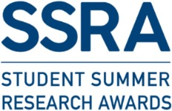

GUIDELINES FOR ETHICAL APPROVAL FOR SSRA PROJECTS

Ethics approval (if required) must be in place before the commencement of all summer research projects.
You must upload the Ethics Declaration Form on Brightspace BEFORE the commencement of your project. This declaration must be completed, even if the project does not require ethical approval.
SSRA students may not be insured unless UCD can verify that the proper ethics protocols have been followed.
For the UCD ethics guidelines, see https://www.ucd.ie/researchethics/policiesguidelines/

SELF-ASSESSMENT
Does your research involve the use of
- Cell lines? No ethical approval required.
- Published papers for review No ethical approval required.
- Human subjects (e.g., survey participants, patients etc.), human data (e.g., clinical data, sequencing data etc.), human tissues, primary cells isolated from humans? See section HUMANS below
- Animals, animal tissue? See section ANIMALS below

An SSRA Ethics Workshop will be held in March 2026 to support students in understanding and addressing the ethical considerations of their SSRA projects.
HUMANS
- Please note, students do not have the right to access medical records which identify patients (e.g., imaging databases that identify patients) for research purposes.
- There must be specific consent from the patient which allows you to have access their records for research.
For research, in order to comply with GDPR and the Health Research Regulations, please note the following:
- All research (even if a health professional survey only) must have ethical approval from the relevant Hospital / Institution Research Ethics Committee (REC).
- Consent is required for all research and data processing.
- RECs will not give retrospective approval for research already commenced/completed.
The retrospective chart review, also known as a medical record review, is a type of analysis that involves the use of pre-recorded, patient-centred data to answer one or more questions.
Retrospective chart reviews can be used for several purposes, i.e., research, clinical audit, service evaluations, etc.
Retrospective chart review conducted for research purposes (must be submitted to a Hospital Research Ethics committee, while those conducted for audit or evaluation purposes should follow the clinical governance path as outlined by their organisation.
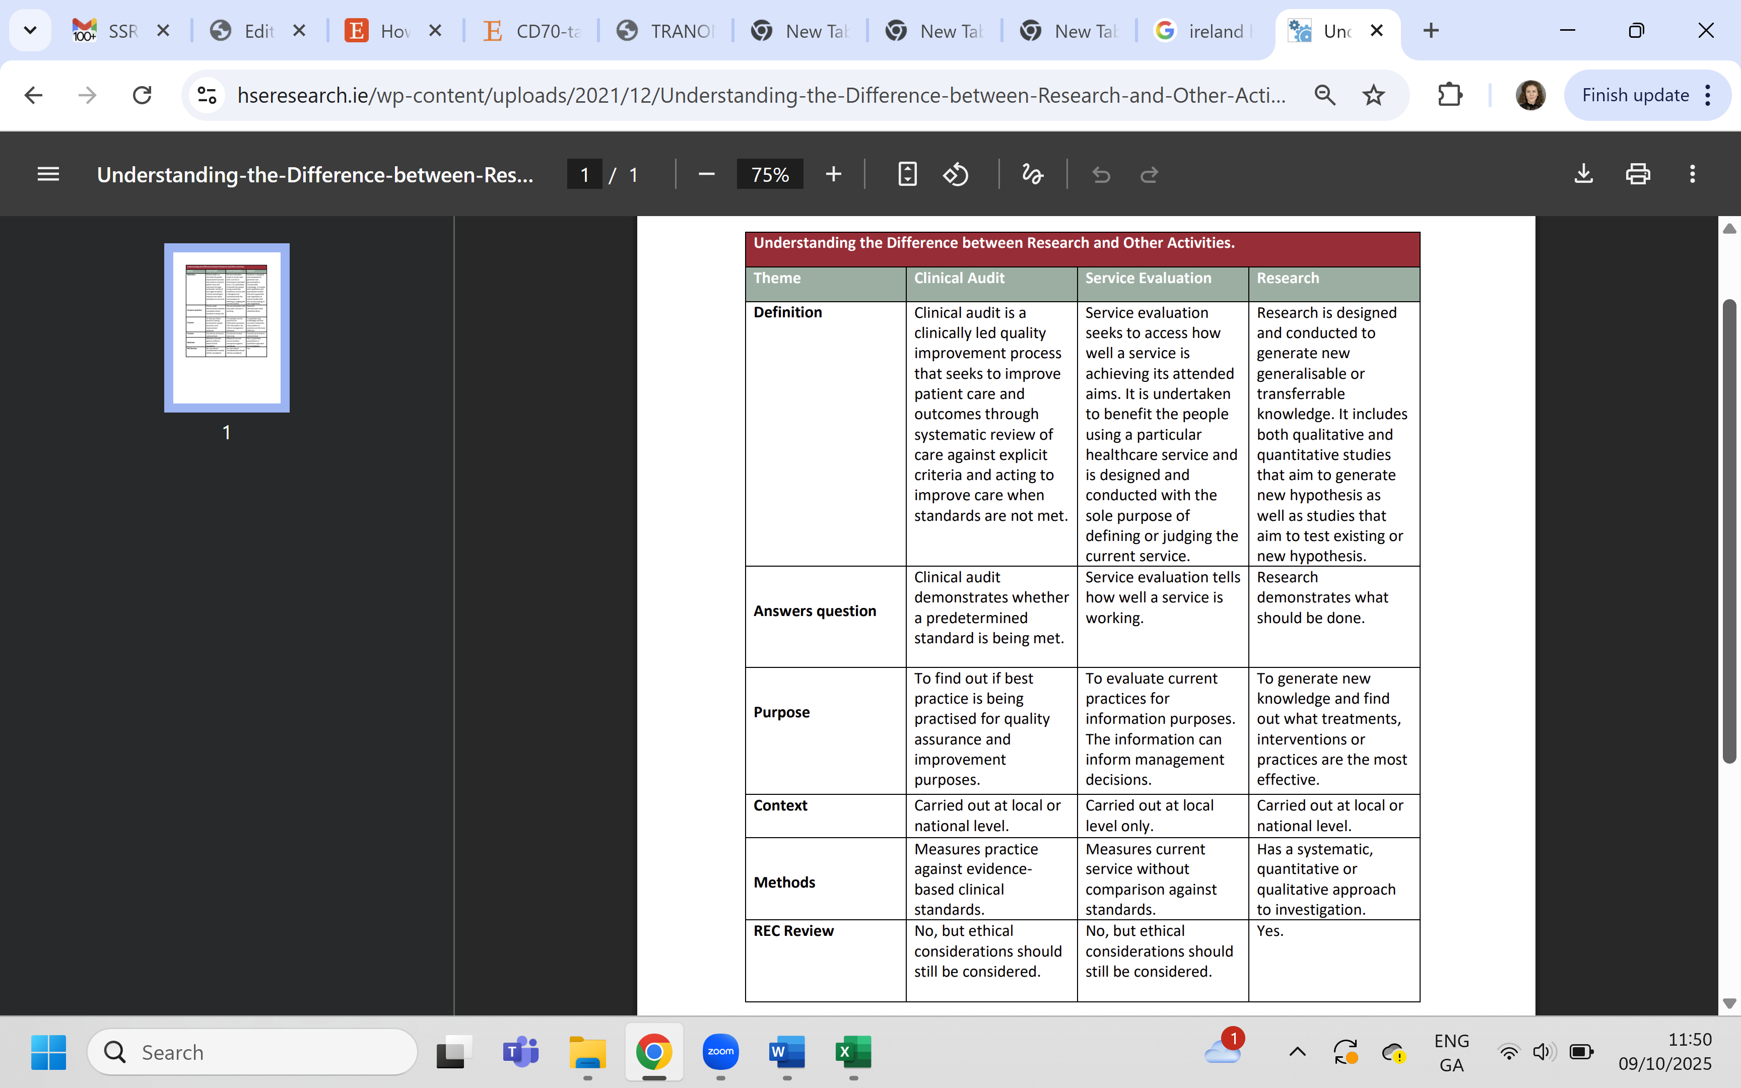Table from www.hseresearch.ie
See Health Research Regulations (S.I. 314 of 2018; S.I. No. 18/2021) for more information. The Department of Health issued the Health Research Regulations S.I. 314 of 2018 which outline how data protection applies to health research. S.I. 18/2021 modify these to apply to the processing of personal data for health research purposes.

The UCD School of Medicine Undergraduate and Taught Masters Research Ethics Committee (UTMREC-SM) is a sub-committee of the UCD Human Research Ethics Committee - Sciences (UCD-HREC-LS). This committee reviews applications for ethical approval, including low risk studies, for research conducted by registered undergraduate and graduate taught students in the School of Medicine on behalf of UCD-HREC-LS, including SSRA projects. The Chair of UTMREC-SM is Associate Professor John Baugh.
For the UCD ethics guidelines, see https://www.ucd.ie/researchethics/policiesguidelines/
Discuss the ethical aspects of your research project with your Supervisor.
- For clinical studies,
- First your supervisor should secure ethical approval from the relevant Hospital / Institution Research Ethics Committee, AND
- Also, afterwards you need to apply for a low risk approval from UTMREC-SM (form H3).

- Some projects involving human participants (who are not patients) may require full ethical review. If you have a UCD Supervisor, you should submit the HR1 form to UTMREC-SM. Please allow enough time for this to take place in advance of the project start date. Deadlines and meeting dates are available on the website.
If you have a non-UCD supervisor, your supervisor should secure approval from the relevant institution first, and then you need to apply for a low risk approval from UTMREC-SM.
Students can find the relevant forms at this address: https://www.ucd.ie/medicine/research/researchethics/howtoapply/

Insurance for Research Involving Human Participants and their Data
Please note, the Insurance Self-Assessment Checklist must be completed by all persons making a Human Research Ethics submission. It applies to both applications for full review and low risk studies.
ANIMALS
If your research involves animals and/or animal tissue, contact Associate Professor John Baugh (john.baugh@ucd.ie).
- Please note that SSRA students are NOT permitted to conduct procedures on living animals as part of their research activity.
- SSRA students may use animal tissue from projects with ethical approval in place (e.g., project authorisation from HPRA in Ireland).

You may need to apply for an Exemption from Full Ethical Review from the Animal Research Ethics Committee (AREC) in UCD.
Grounds for exemption:
- use of animal tissue from projects with ethical approval in place (e.g., ethics approval from HPRA in Ireland);
- no procedures are being carried out;
- the use of clinical samples (where procedures are not carried out for the purpose of research).
In Ireland, the use of living animals in research is regulated by S.I. No. 543 of 2012, which transposes the EU's Directive 2010/63/EU into national law.
“animal” means
- any live non-human vertebrate animal, including
- an independently feeding larval form,
- (ii) a foetal form of mammal as from the last third of its normal development,
- any animal at an earlier stage of development than that referred to in subparagraph (a), where the animal is to be allowed to live beyond that stage of development and, as a result of the procedures performed, is likely to experience pain, suffering, distress or lasting harm after it has reached that stage of development; or
- any live cephalopod.

“procedure” means any use, invasive or non-invasive, of an animal for experimental or other scientific purposes, with known or unknown outcome, or educational purposes, which may cause the animal a level of pain, suffering, distress or lasting harm equivalent to, or higher than, that caused by the introduction of a needle in accordance with good veterinary practice. This includes any course of action intended, or liable, to result in the birth or hatching of an animal or the creation and maintenance of a genetically modified animal line in any such condition but excludes the killing of animals solely for the use of their organs or tissues.

SSRA ETHICS DECLARATION FORM

Submit this completed form on Brightspace no later than 2 June 2026, before your project begins. Ensure all sections are completed clearly and upload this page only.
Name:
Student No:
Project Title:
Supervisor:
- Does your research involve the use of
- human subjects, human data, human tissues, primary cells isolated from humans
AND/OR
- animals, animal tissue?
YES |  |  |  |  | No
- Does your project require ethics approval?
YES |  |  |  |  | No
2.a.) If YES, please provide an UTMREC-SM (or AREC) reference number:
2.b.) If NO, please provide justification:
- Have you completed the Insurance Self-Assessment Checklist and has your Supervisor signed it?
YES |  |  | No |  |  | N/A
Project Supervisor Signature:
Print Name:
Student Signature:
Print Name:
Date:

